# What is git?

Git is the free and open source distributed version control system that's responsible for everything GitHub related that happens locally on your computer.

# 1)what are the other platform same as a github to version and maintain your code?

**platforms like GitHub** that are used for **version control, code hosting, and collaboration**

GitLab: **Best for:** All-in-one DevOps lifecycle.

Bitbucket:

SourceForge

AWS CodeCommit

Azure Repos :

# 2)git init

• It **creates a hidden folder** named .git in your directory.

• This .git folder contains all the metadata (version history, configs, logs, etc.) required to track changes in your code.

# 3)what is inside the .git folder?

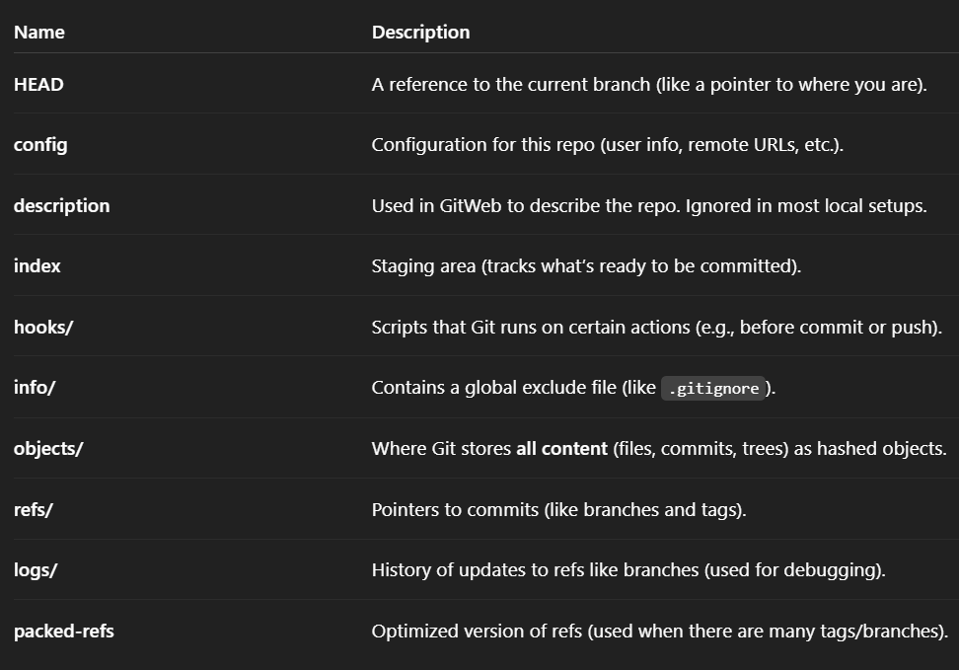

# 4) What is the use of the git status command

The git status command is used to **check the current state of your working directory and staging area**.

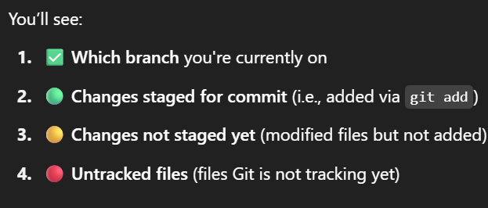

Useful for if any changes are made after the git commit(modified file tracks)

# 5) use of git add .

“Stage **all changes** (new files, modified files, and deletions) in the **current directory and subdirectories** for the next commit.”

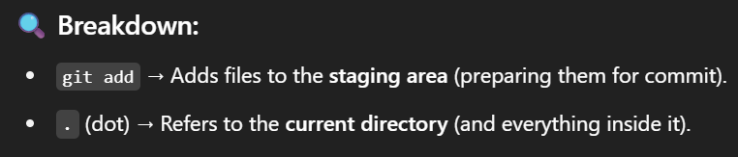

For a particular file if you want to add then command is git add <filename>

# 6) git commit –m “new commit”

The git commit -m command is used to **save (commit) your staged changes** in Git **with a message**.

# 7) If you want to remove the stage of current file then you write git restore

git restore --staged <filename>

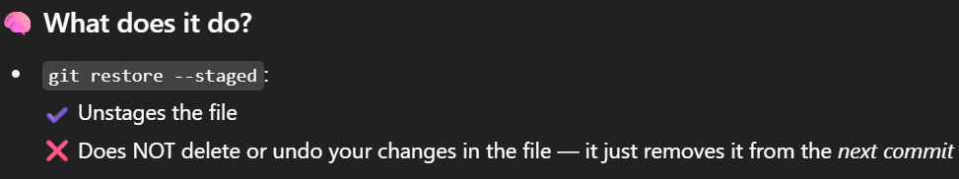

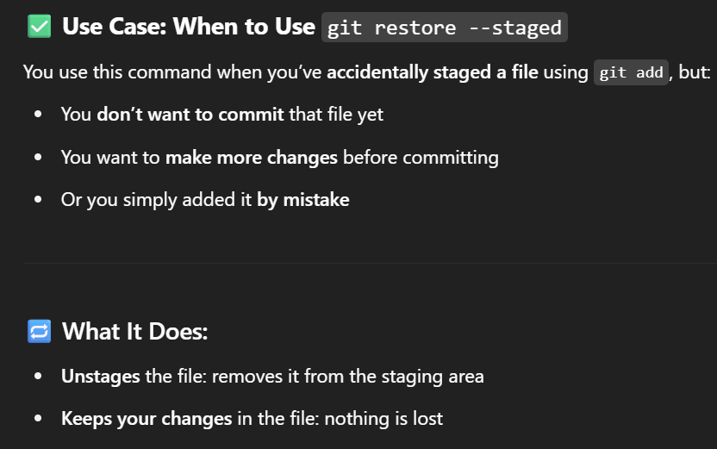

# 8) git log

The git log command is used to **view the history of commits** in a Git repository.

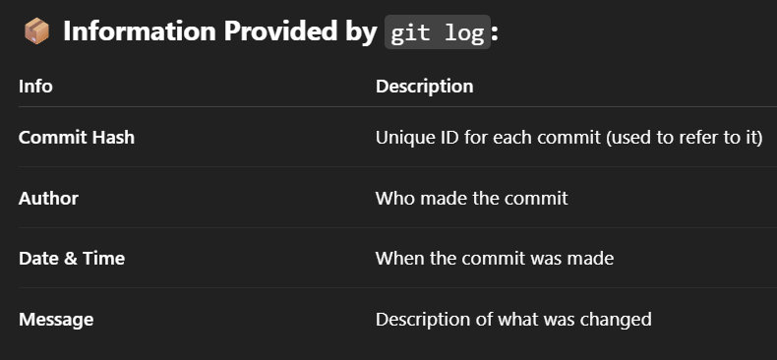

# 9) if you want to remove the last commit because the file has been deleted by mistake then how can you do it?

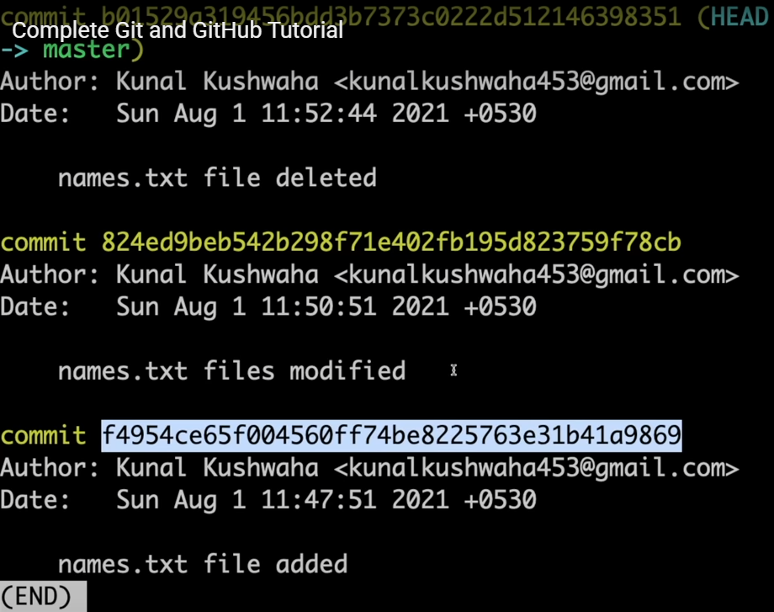

Suppose here you want to delete last two commits then

Then copy the hash before that last two commits

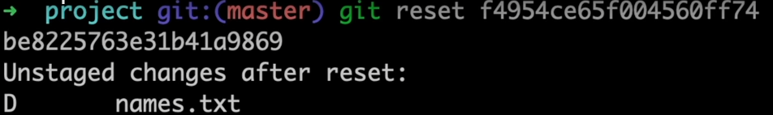

Then again you check git log now you will be only see the one commit

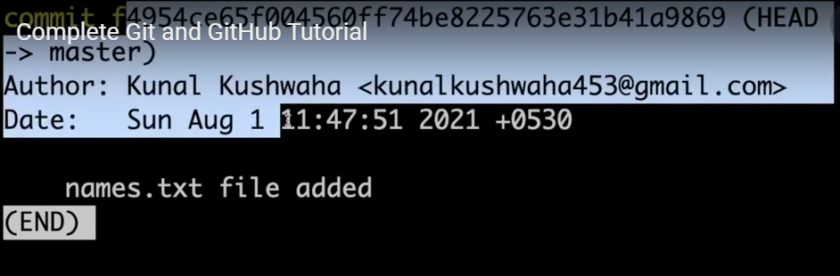

# 10) where these all changes has gone?

In the unstaged area

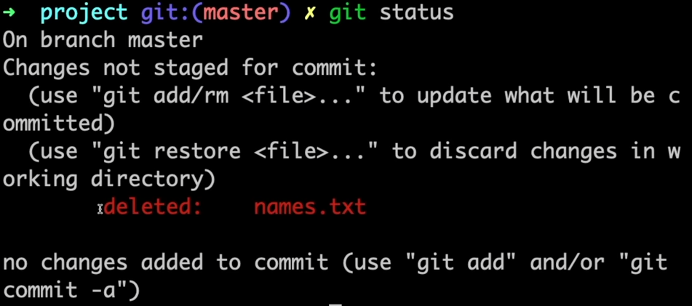

# 11) If you want that your progress or a feature of the project that code you have written , is there is anyway so that put your work somewhere else without making a commit and history and whenever you want that things back you get it

Command : git stash

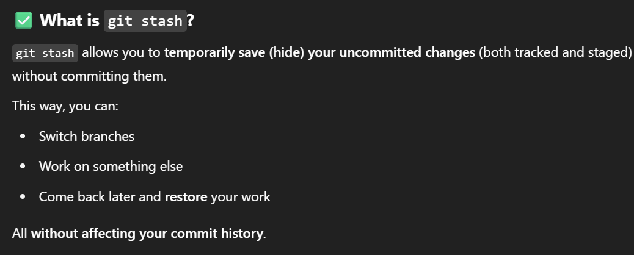

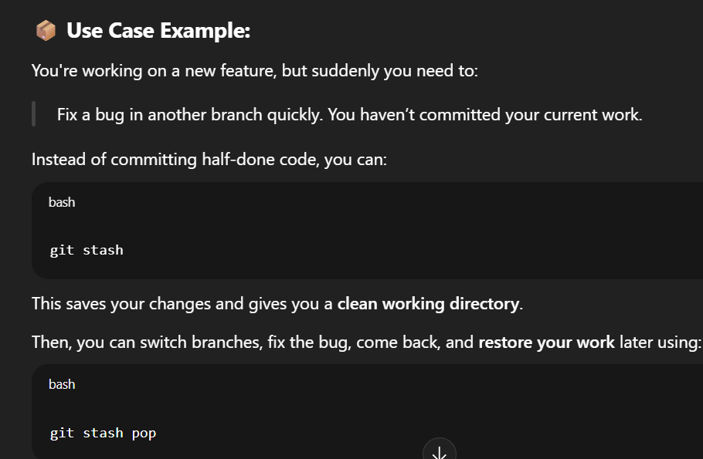

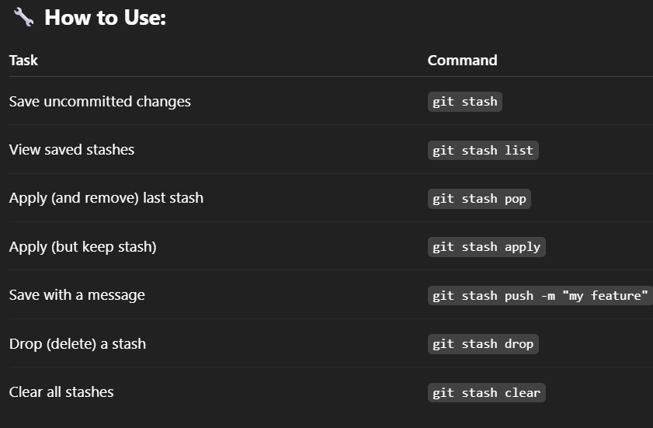

If you do not want to lose your current status of the git and also do not want that changes in your repo You just saying like just go a back to the stage and when I need I will call for you

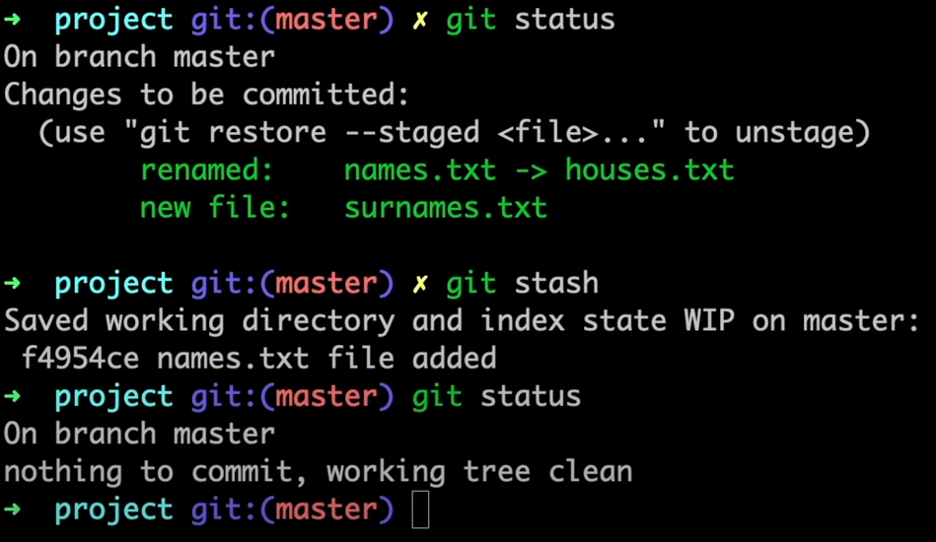

# 12) for calling stash in project folder

Command: git stash pop

# 13)if you want to clear or remove the stash which you have stored then

Command: git stash clear

# 14) to add project on github repo

Command: git remote add origin <link of repo>.git

# 15)If you want to see the link which is associated with this folder then command is

Command: git remote –v

# 16)for push code in the repository

Command: git push origin <branch name_master>

# 17)how to create a branch

Command: git branch <branch name>

# 18)how to change the branch

Command: git checkout <branchname>

Means head is changing towards the branch name that you have provided

Note: Whenever you are creating a new branch at that time the new branch is created from your head is currently pointing

# **Create a new branch** with the given name **and switch to it immediately**.

git checkout -b feature1

# 19) How to clone the repository which is already exist

Command: git clone <link>

# 20)Why we required to clone the repository

Because whenever you are trying to add some code in some organization you did not able to push the code into the directly main repository It is so risky for that organization , so for that first of all you have to fork that repository into your github account after that you can change the code by your own on your repo

# 21) From where you have forked the repository that is known as upstream url

And how to add upstream url

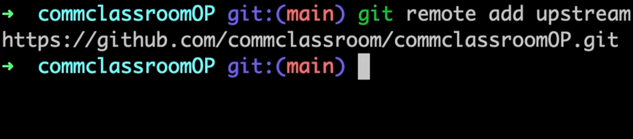

# 22) If you have created a type of branch separately and add one feature on that and you want to merge that feature on the main branch then how can you do it

For that you need to create pr request

Note: If one branch is if one branch is <main> and another branch is <new feature> then if <new feature> branch has made a request to push the code onto the main branch only one time pull request has been created And after that again if you commit some other things onto the <new feature> branch at that time new pull request is not being generated it is automatically added into the main branch

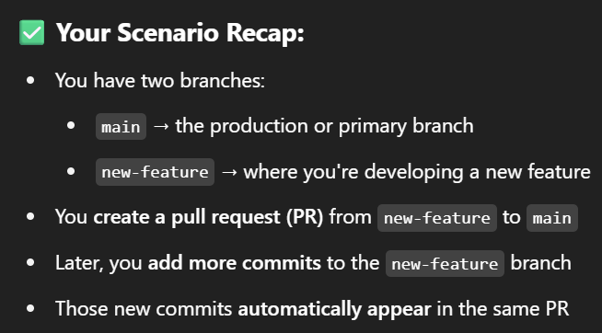

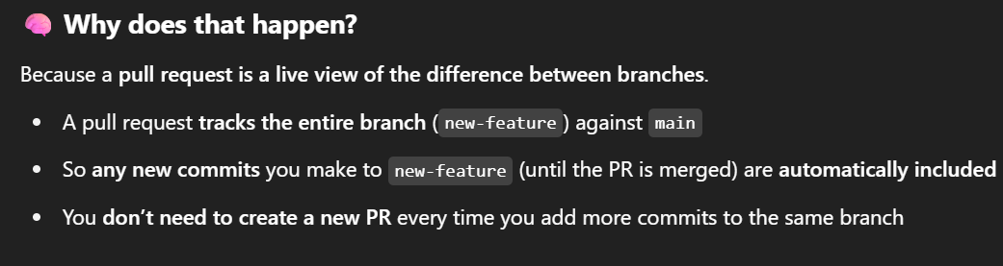

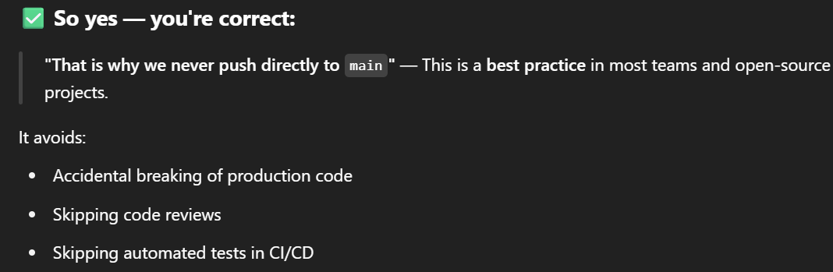

# 23) At a time only one pr is open

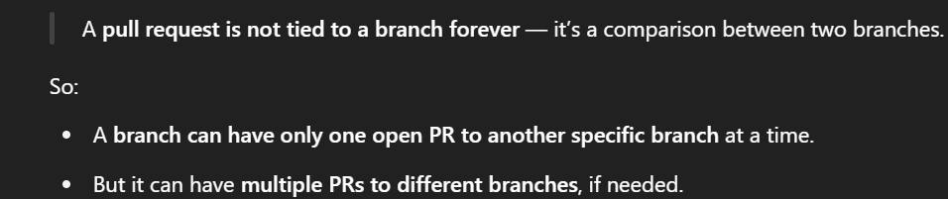

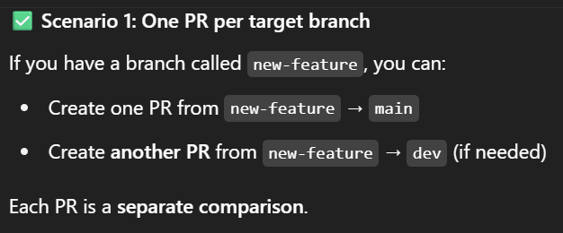

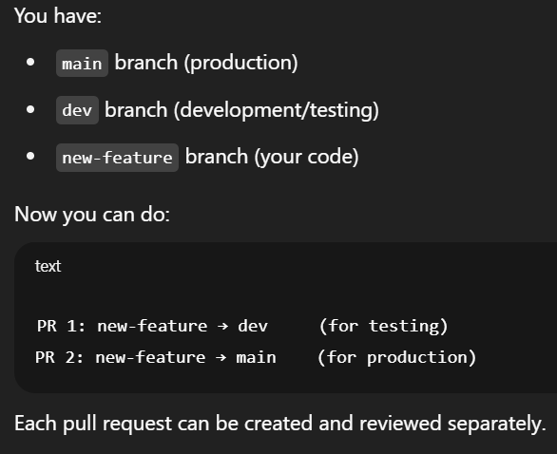

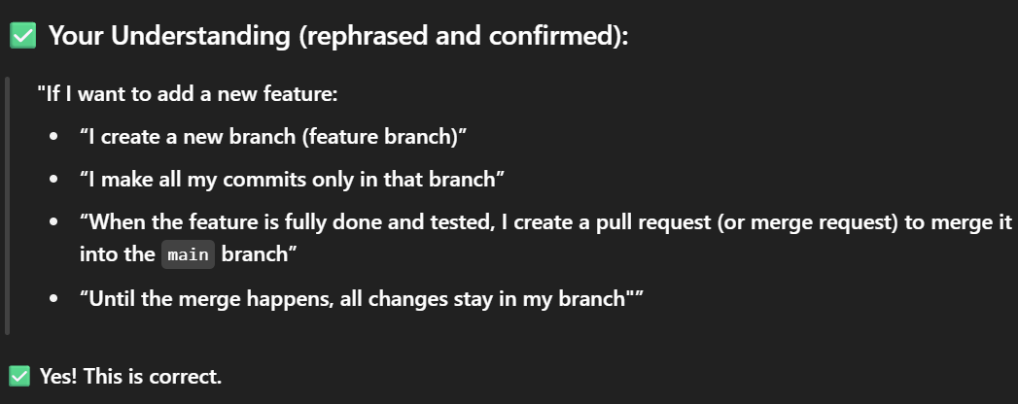

# 24) But I have confused in that if I feel like I have completed my feature and after the code reviewer says that you have to add these things and I have to add those things into the my branch but I have already created one pr for pushing my code already with the main branch so if I commit the new changes in my branch that is also reflected on the main branch?

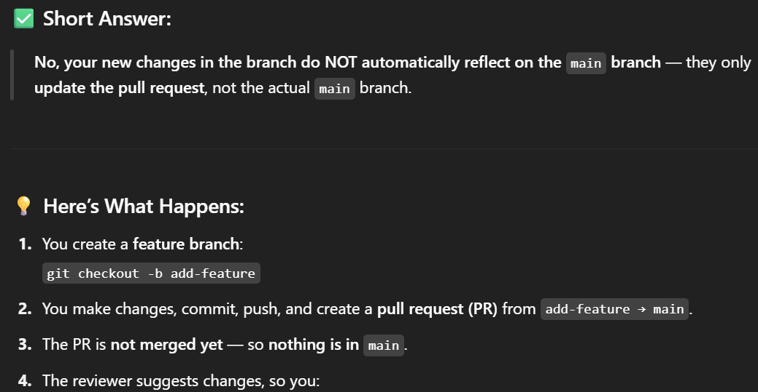

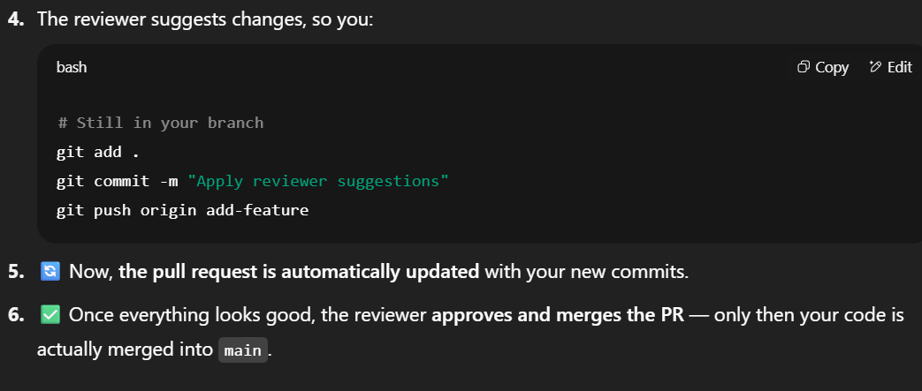

# 25) merging main branch with my feature branch and after two months the client says that I want these changes in this feature so I have already created pr previously I have just explained then I need to change the code or change the new feature then in that case what should be done

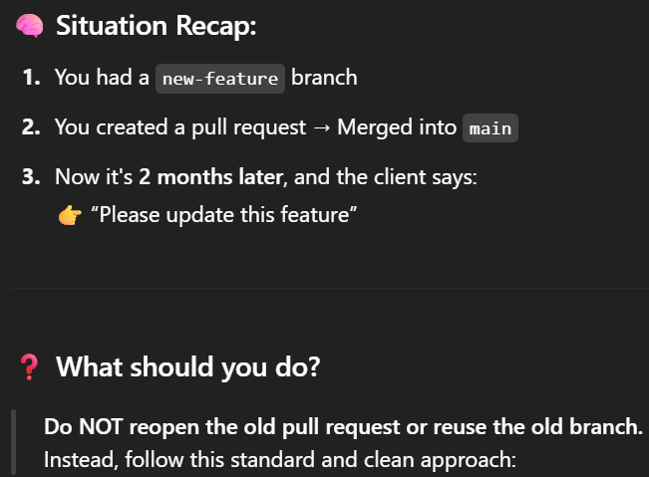

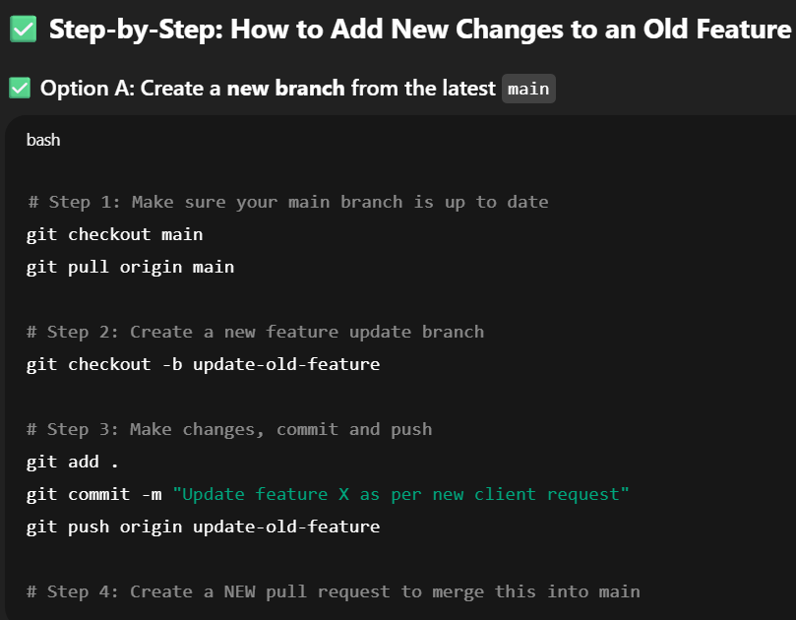

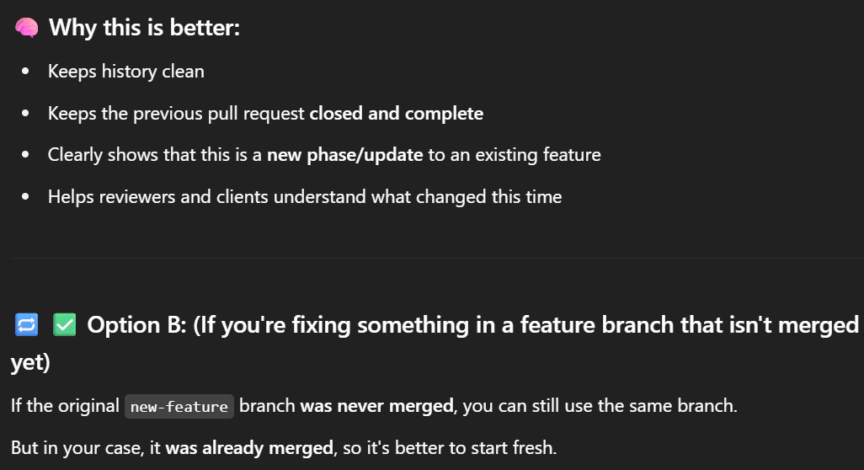

# 26)

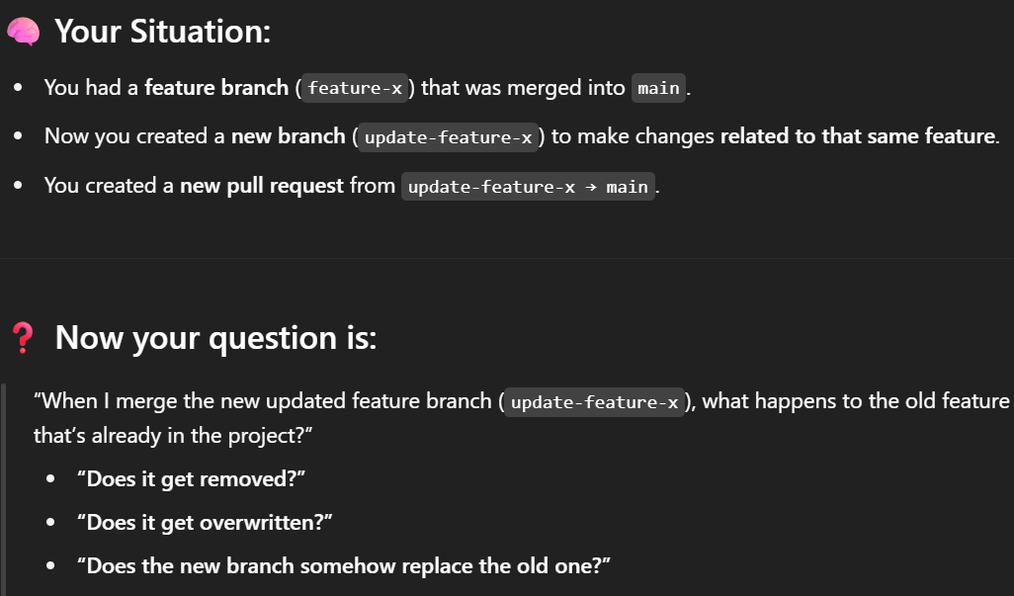

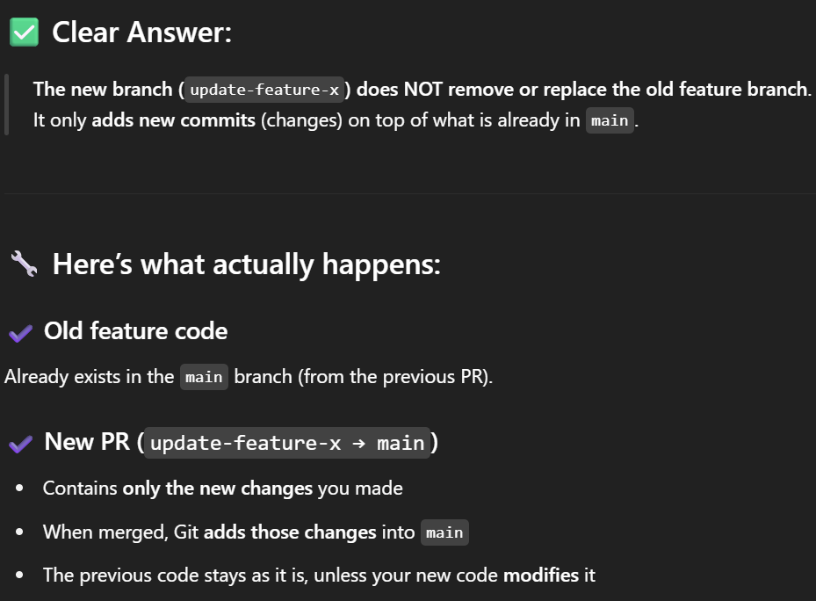

27)if update like open source project of kubernetes has accept some request of one of the user then definitely it will not reflect onto your local branch or the repo that you have forked in your machine or github account because you have forked before the merging that code so for that what do you use ?



You can go to your github account and do with ui or you can also with do with manual step



Now reset the main branch of your origin to the main branch of the upstream

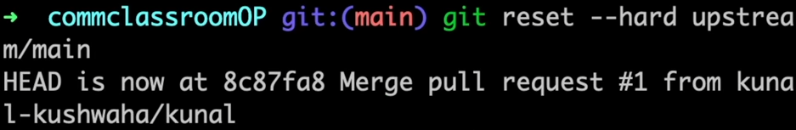

You can also runs git pull upstream main but there is a difference between these two commands

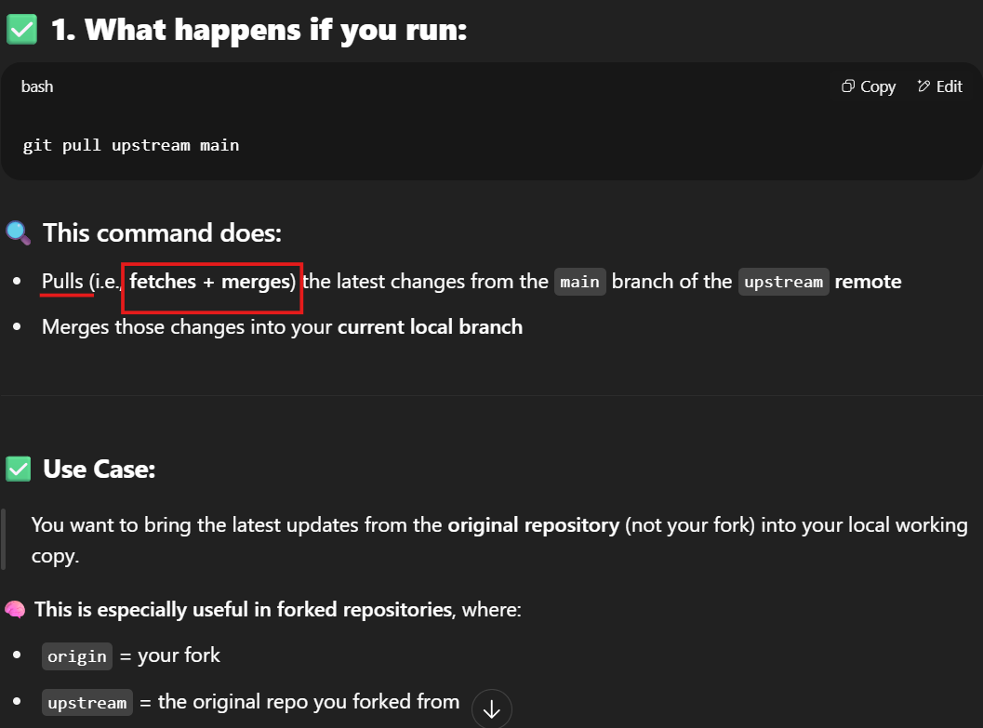

# 28)Difference between git fetch and git pull

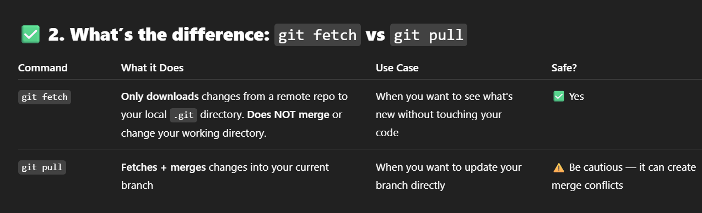

# 29)rebase command

If I have created one file “1” and then commit ,again created file “2” and commit , again created file “3” and commit, again created file “4” and commit

But now I want to merge that all four commits into the one commit then using rebase –i you can use it

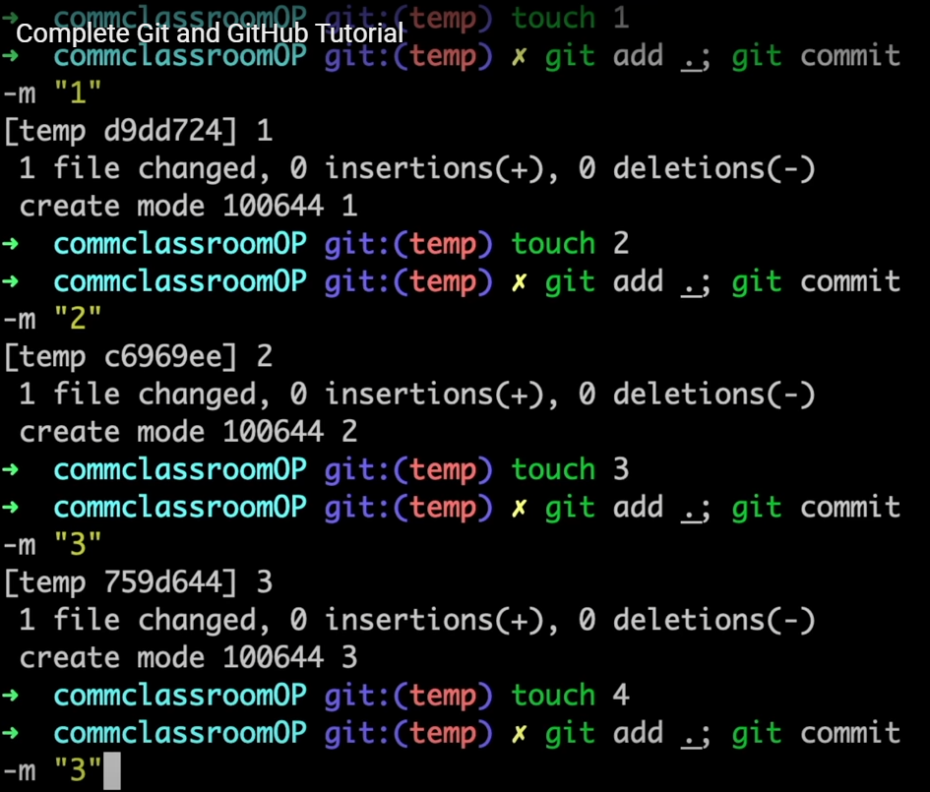 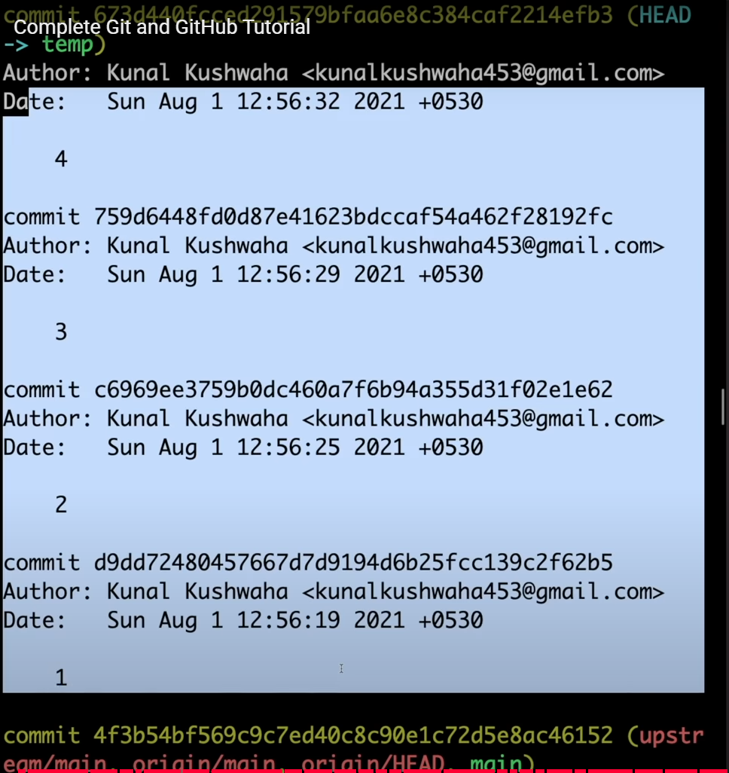

I want to merge all these 4 commit into a single commit



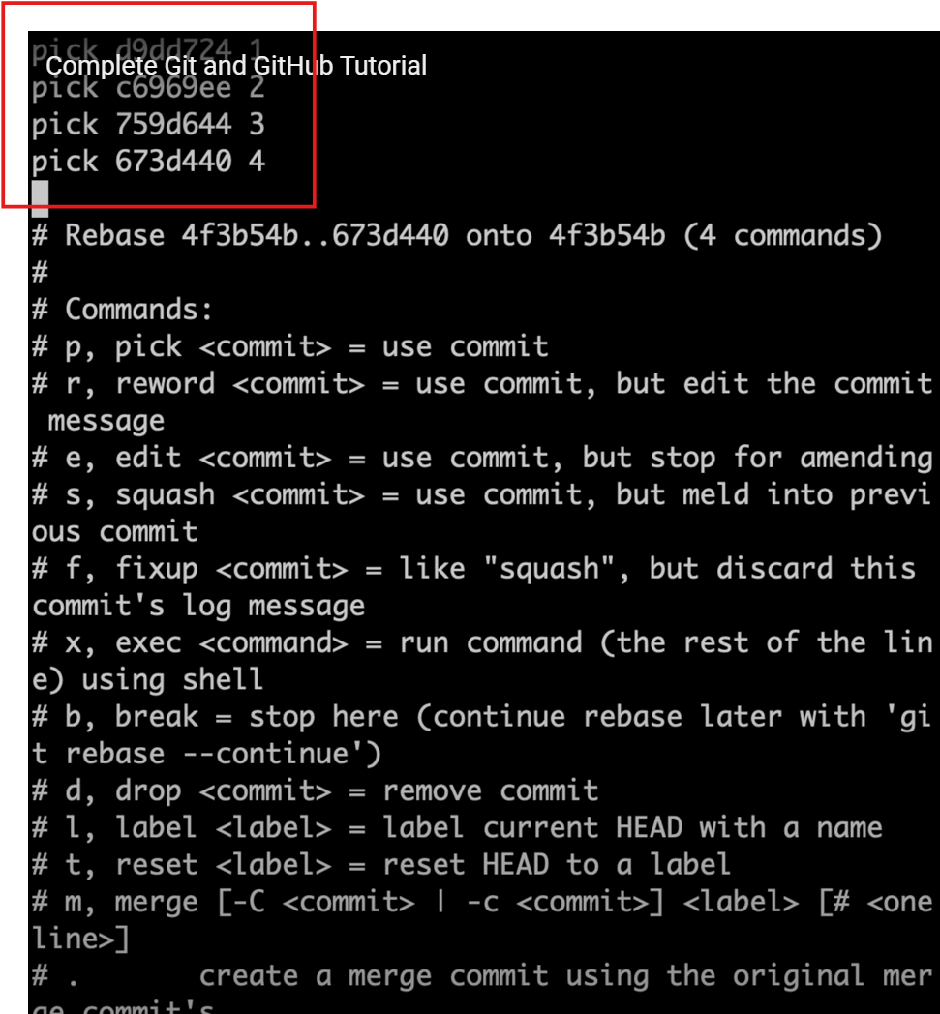 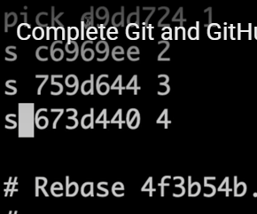

Then change the pick here to squash and update the code like in the ss

Squash means about a squash commit merge into that pick commit

Means here it is three squash has been merged in first pick

# 30)merging conflicts

These conflict often happen when if one user has changed the code in line number 3 and another people have also changed the code in line number three at that time git will ask you to help which changes should be done

# Another screenshots of the interview questions

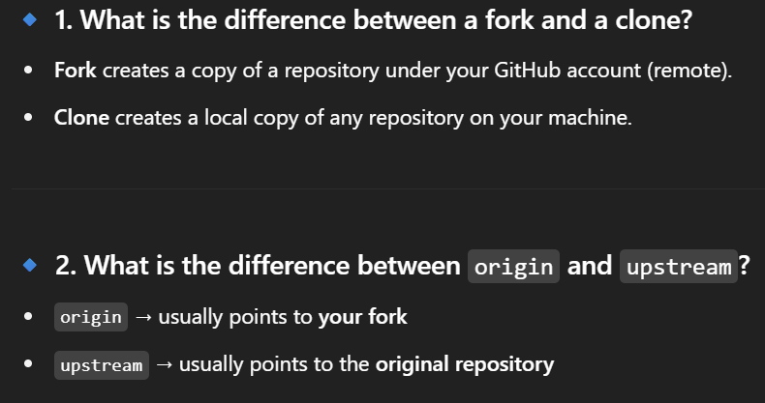

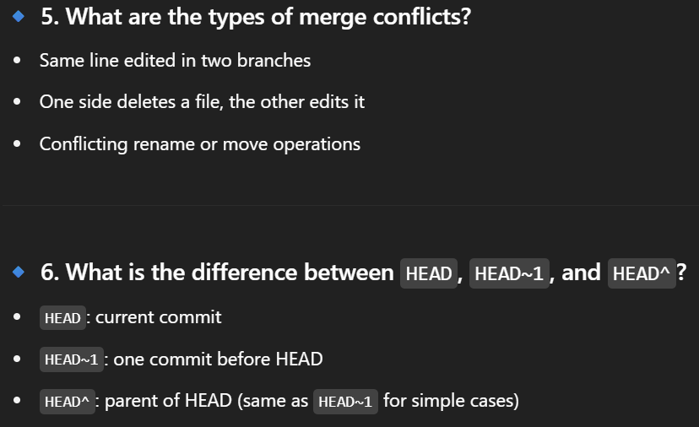

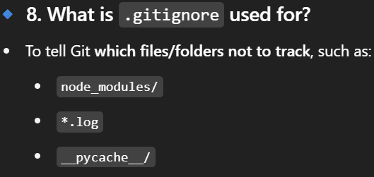

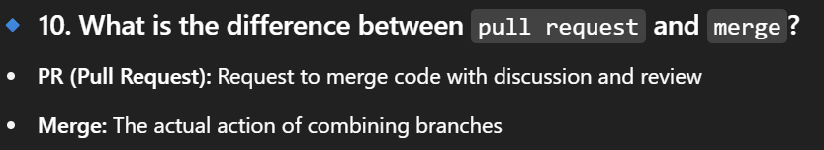

# Example of git reset vs git revert

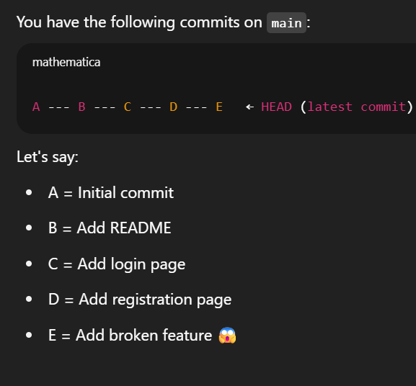 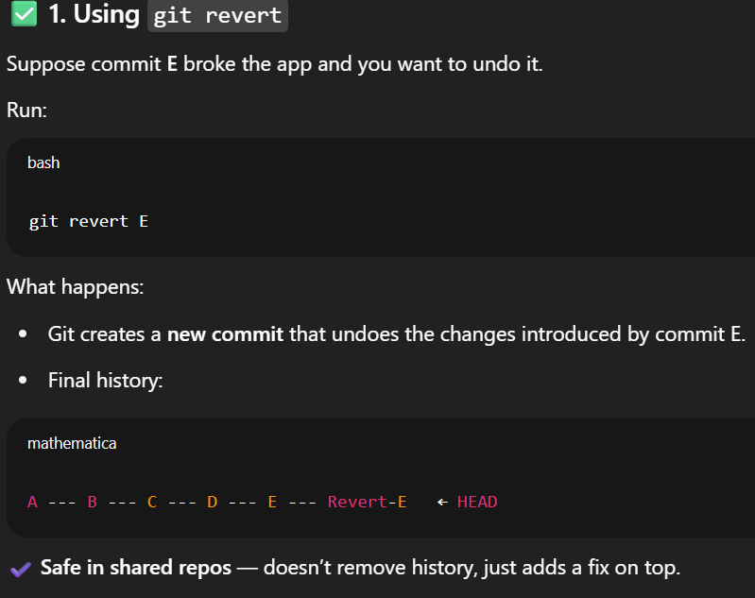

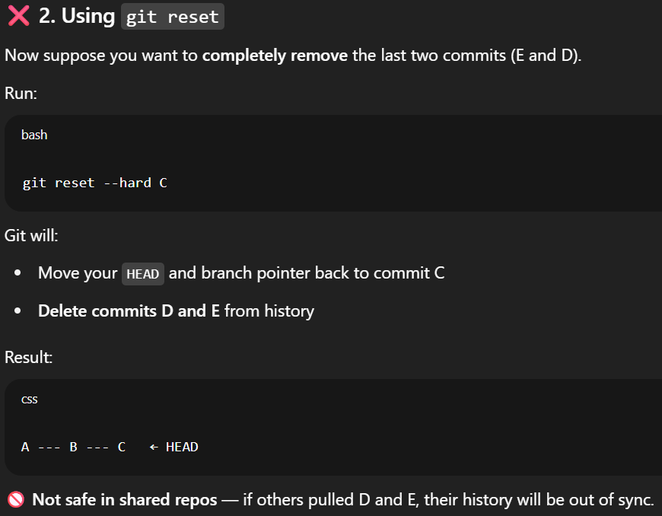

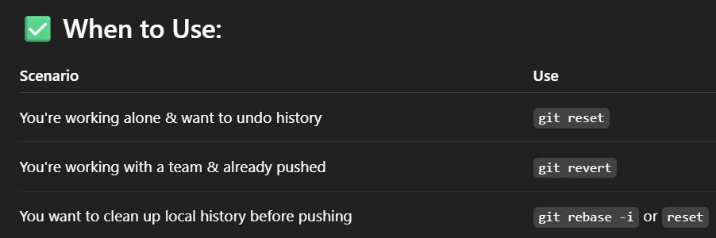

Chat link of chatgpt of git and github manually:

<https://chatgpt.com/share/6854f029-3ebc-8002-bbe6-2e0292d127ba>

git cheatsheet ss

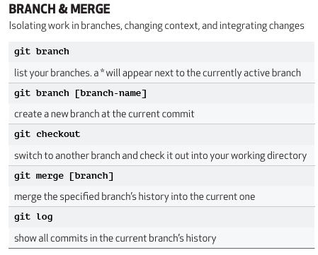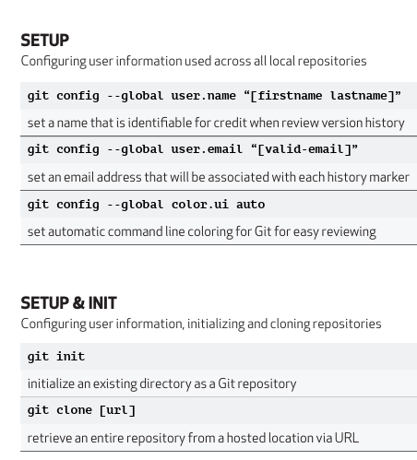

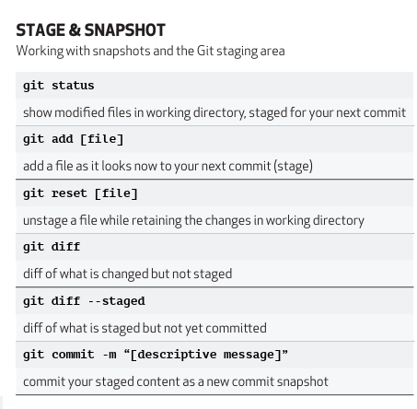 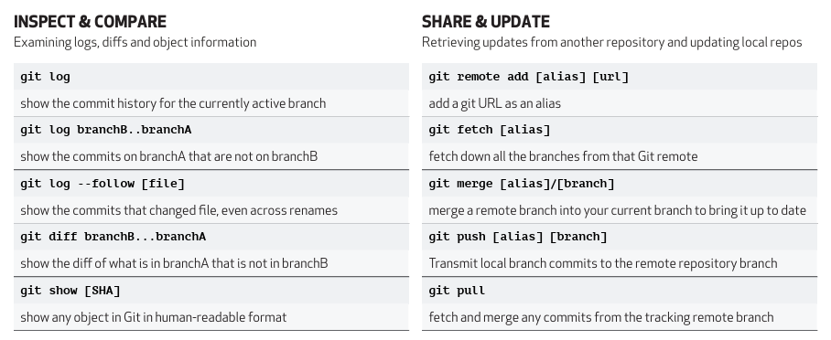

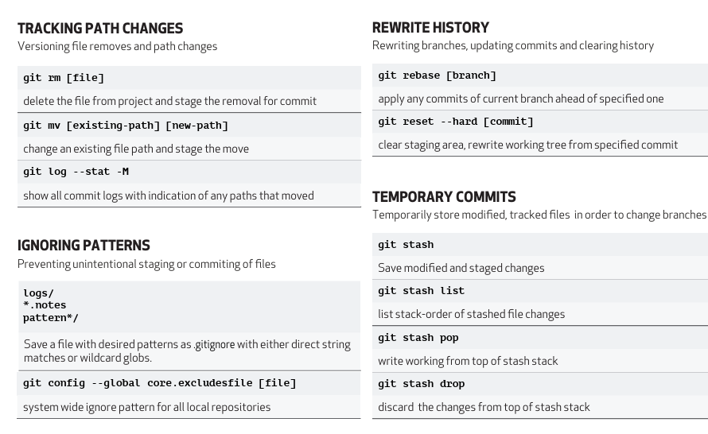

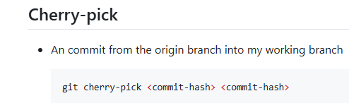

# Git commands link:

<https://github.com/Bhavya2520/DevOps-Learning/blob/main/docs/git/commands.md>